**Jeffrey Saletnik**

**Indiana University**

**Department of the History of Art**

**1201 East 7th Street**

**Bloomington, IN 47405**

[**jsaletnik@gmail.com**](mailto:jsaletnik@gmail.com)

**Black Mountain College, USA Word Count: 1,009**

Between 1933 and 1957 Black Mountain College served as an unlikely crucible of modernism. Despite its isolated location near Asheville, North Carolina, at various times its permanent and summer faculty included the likes of Anni Albers, Josef Albers, Ilya Bolotowsky, Jean Charlot, Lyonel Feininger, Joseph Fiore, Buckminster Fuller, Walter Gropius, Karen Karnes, Franz Kline, Willem de Kooning, Jacob Lawrence, Robert Motherwell, Beaumont Newhall, Amédée Ozenfant, Xanati Schawinsky, Ben Shahn, and Jack Tworkov. These artists and architects were joined by composers John Cage, Lou Harrison, Ernst Krenek, David Tudor, and Stefan Wolpe; writers and poets Robert Creeley, Charles Olsen, and M. C. Richards; as well as critic Clement Greenberg, musicologist Heinrich Jalowetz, and choreographer Merce Cunningham. There are few evident commonalities among the practices of this mix of European émigrés and Americans, yet the educationally progressive ethos of the College appealed to each of them. Its founding program was predicated upon a belief that the arts were central to higher education and that the practice of democracy would benefit from their curricular integration. Participation was prioritised in all activities, particularly in learning. As John Andrew Rice, one of the school’s founders, claimed: “To read a play is good, to see a play is better, but to act in a play however awkwardly is to realise the subtle relationship between sound and movement”.

Instruction began at the Blue Ridge Assembly campus of the College in fall 1933. Rice, Theodore Dreier, and other alienated faculty of Rollins College aspired to create an environment in keeping with the educational principles of philosopher John Dewey (1859-1952). Dewey’s ethics encouraged hands-on learning activities directed toward each individual’s abilities and thus was antithetical to centralised teaching methods. Although priorities changed during the school’s thirty-seven year history, some semblance of this attitude remained present in both the College’s curriculum and its sociology. In addition to coursework in various subjects, students developed an individualised curriculum in consultation with the faculty and participated in interdisciplinary seminars. Students were unaware of their grades; comprehensive examinations required to graduate were evaluated by external reviewers rather the College faculty. In 1941, the College moved to a new campus on Lake Eden. In advance of the move, students and faculty physically laboured to ready the site, which included their building a three-story studies building. As had been the case at the Blue Ridge campus, the new site included a small farm to provide food for faculty and students. As they had since the inception of the College, faculty and students resided on school grounds; they dined and socialised together. Academic life and daily life were integrated, although this became less of a priority in later years of the school’s existence.

The College’s arts curriculum was particularly significant. Josef Albers and Charles Olsen were among the most influential permanent members of the faculty. (Many associated with the College, like John Cage, Buckminster Fuller, and Willem de Kooning, taught only at the College’s primarily arts-oriented summer sessions and institutes.) Albers, who had studied as well as taught at the Bauhaus, was brought to the College to develop its visual arts curriculum in 1933. He remained at the school until 1949. Albers introduced a material-oriented, process-based means of instruction meant to attune students to the properties of various visual material. He developed a relational program of color instruction at the College that ultimately would be published as the well-known text *Interaction of Color* (1963). Olsen, who joined the College faculty in 1948, advanced the notion of “projective verse” and, by extension, poetry that enabled a reader’s direct engagement with a text. He became the College rector in 1953, after which the school became increasingly literary in its orientation. Another poet teaching at the College, Robert Creeley, edited the *Black Mountain Review* (1954-57), a magazine known for its employment of experimental verse. In addition to the visual arts and poetry, the College’s music curriculum was substantial. In summer 1944, Heinrich Jalowetz organized an institute that brought together prominent musicians in celebration of the seventieth birthday of composer Arnold Schoenberg (1874-1951), who had revolutionized musical composition by introducing serial twelve-tone technique in the early twentieth century. During the summer of 1948, Cage organized a festival devoted to the music of Erik Satie (1866-1925). He presented his infamous lecture “Defense of Satie” and performed Satie’s compositions for piano; the College staged Satie’s paly “The Ruse of Medusa,” which starred Fuller, Elaine de Kooning, and others in residence for the summer.

The College was officially dissolved in 1957, just as faith in the essentialist value system that underscored its founding principles began to wane and, ironically, despite the College having hosted activities considered precursors for avant-garde practices in the 1960s. During the summer of 1952, for instance, Cage, Merce Cunningham, Robert Rauschenberg (a student), and others mounted an “untitled event” now regarded as central to the proto-history of Happenings and Fluxus art and performance. The success of the school’s students is also noteworthy; in addition to Rauschenberg, they include artists Ruth Asawa, Ray Johnson, Kenneth Noland, Dorothea Rockburne, and Cy Twombly.

**References and further reading**

Dewey, A. D. (2007) *Beyond Maximus: The Construction of Public Voice in Black Mountain Poetry*, Stanford: Stanford University Press.

Díaz, Eva (2014) *The Experimenters: Chance and Design at Black Mountain College*, Chicago: University of Chicago Press.

Duberman, M. (1972) Black Mountain College: An Exploration in Community, New York: Dutton.

Harris, M. E. (1987) The Arts at Black Mountain College, Cambridge, Mass.: MIT Press.

Harris, M. E., et al. (2005) *Starting at Zero: Black Mountain College, 1933-57*, Bristol: Arnolfini Gallery; Cambridge: Kettle's Yard Gallery.

Katz, V. (ed.) (2002) *Black Mountain College: Experiment in Art*, Cambridge, Mass.: MIT Press.

Lane, M. (ed.) (1990) *Black Mountain College: Sprouted Seeds, An Anthology of Personal Accounts*, Knoxville: University of Tennessee Press.

Molesworth, H., et al. (2015) *Leap Before You Look: Black Mountain College 1933-1957*, Boston: The Institute of Contemporary Art; co-publisher TBD, likely [New Haven: Yale University Press]; add when confirmed summer 2014.

Reynolds, K (1998) *Visions and Vanities: John Andrew Rice of Black Mountain College*, Baton Rouge: Louisiana State University Press.

Image:

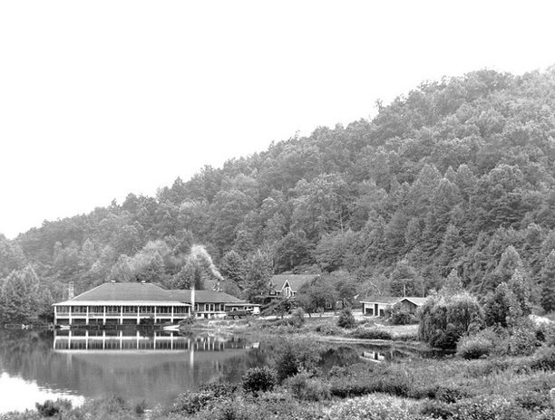

See:

http://www.flickr.com/photos/north-carolina-state-archives/3762271737/

Caption:

Dining Hall, Lake Eden, Black Mountain College, 1940's

Source:

Black Mountain College Research Project Papers, Visual Materials, Box 90, North Carolina State Archives, Raleigh, NC.